

Write your name below:

_______________________________________________

**Hale School**

**Year 11 Semester 1 Examination, 2016**

**Mathematics   
Methods**

**Circle your teacher**

**VMU MPC RPT AGC SAV BAH**

**Section One:  
Calculator-free**

**Booklet 1 of 3**

TIME ALLOWED FOR THIS SECTION

Reading time before commencing: Five minutes  
Working time for paper: Fifty minutes

**MATERIAL REQUIRED/RECOMMENDED FOR THIS PAPER**

|  |  |
| --- | --- |
| **For Examiners only** | |
| Section 1 |  |
| Section 2 |  |
| Total |  |

*TO BE PROVIDED BY THE SUPERVISOR*

This Question/Answer booklet.

Formula Sheet.

*TO BE PROVIDED BY THE CANDIDATE*

*Standard Items*: pens (blue/black preferred), pencils (including coloured), sharpener,   
 correction fluid/tape, eraser, ruler, highlighters

*Special Items*: nil

**IMPORTANT NOTE TO CANDIDATES**

No other items may be taken into the examination room. It is your responsibility to ensure that you do not have any unauthorised notes or other items of a non-personal nature in the examination room. Please check carefully, and if you have any unauthorised material with you, hand it to the supervisor **BEFORE** reading any further.

**STRUCTURE OF THIS PAPER**

|  |  |  |  |  |  |
| --- | --- | --- | --- | --- | --- |
| Section | Number of questions available | Number of questions to be answered | Working time (minutes) | Marks available | Percentage of exam |
| Section One:  Calculator-free | 8 | 8 | 50 | 53 | 37 |
| Section Two:  Calculator-assumed | 13 | 13 | 100 | 90 | 63 |
|  | | |  | **Total** | 100 |

**INSTRUCTIONS TO CANDIDATES**

1. Write your answers in this Question/Answer Booklet.
2. You must be careful to confine your responses to the specific questions asked and to follow any instructions that are specific to a particular question.
3. Spare pages are included at the end of this booklet. They can be used for planning your responses and/or as additional space if required to continue an answer.

● Planning: If you use the spare pages for planning, indicate this clearly at the top of the page.

● Continuing an answer: If you need to use the space to continue an answer, indicate   
 in the original answer space where the answer is continued, i.e. give the page number.

Fill in the number of the question that you are continuing to answer at the top of the page.

1. Show all your working clearly. Your working should be in sufficient detail to allow your answers to be checked readily and for marks to be awarded for reasoning. Incorrect answers given without supporting reasoning cannot be allocated any marks. For any question or part question worth more than two marks, valid working or justification is required to receive full marks. If you repeat any question, ensure that you cancel the answer you do not wish to have marked.
2. It is recommended that you do not use pencil, except in diagrams.

Section One: Calculator Free 53 marks (37%)  
This section has 8 questions. Answer all questions. Write your answers in the spaces provided.  
Working time: 50 minutes  
_______________________________________________________________________________

**Question 1 6 marks**

1. State the exact value of $\cos{(\frac{2π}{3})}$. (1 mark)
2. Convert $15°$ to radians. Simplify your answer. (1 mark)
3. Solve ${3x}^{2}-14x=-8$ (2 marks)
4. Solve $\frac{3b}{4}-\frac{1}{5}=\frac{b}{2}$ (2 marks)

**Question 2 10 marks**

Consider the following graphs:

1. Match each graph above to its corresponding equation below. (4 marks)

|  |  |  |  |  |
| --- | --- | --- | --- | --- |
| **Equation** |  |  |  |  |
| **Graph** |  |  |  |  |
| **Equation** |  |  |  |  |
| **Graph** |  |  |  |  |

**Question 2 continued next page**

**Question 2 continued**

1. Use the graphs to find the value of each of the constants *b*, *c*, *g, h, k* and *l* in the equations on the previous page. Enter the results in the table below

(3 marks)

|  |  |  |  |  |  |
| --- | --- | --- | --- | --- | --- |
| ***b*** | ***c*** | ***g*** | ***h*** | ***k*** | ***l*** |
|  |  |  |  |  |  |

1. (i) State whether the following is a graph of a function or not. (1 mark)

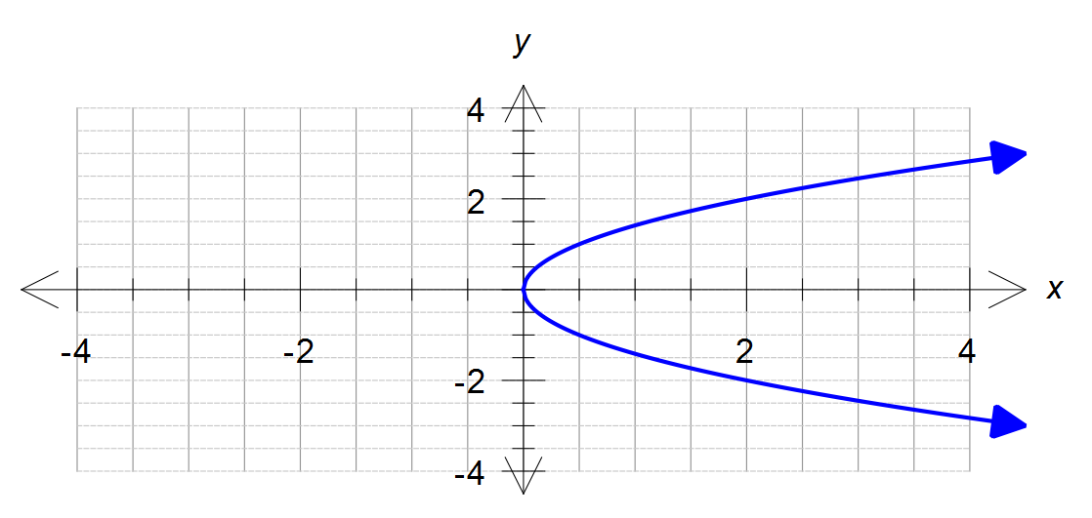

1. State the equation of the above graph. (2 marks)

**Question 3 7 marks**

1. Given the function f(x) = 3x – x2 then determine: (3 marks)
2. f(-2)

(ii) m, if f(m) = -4

1. State the natural domain and corresponding range of: (4 marks)

(i) f(x) = $-\sqrt{x+2}$

(ii) g(x) = 2(x -3)2 + 4

**Question 4 4 marks**

1. Solve using the quadratic formula. Leave your answer in the exact form. (2 marks)

${2x}^{2}-6x-21=0$

1. Solve by completing the square. Leave your answer in the exact form. (2 marks)

$x^{2}+6x=16$

**Question 5 5 marks**

State the equation of each graph shown below.

1. (2 marks)

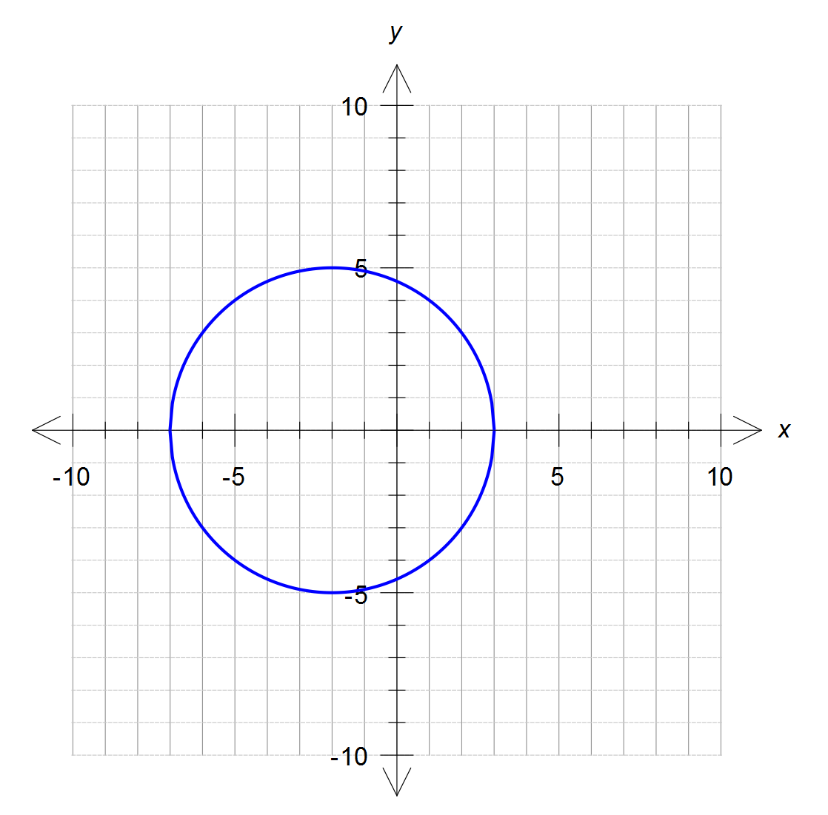

1. (3 marks)  
   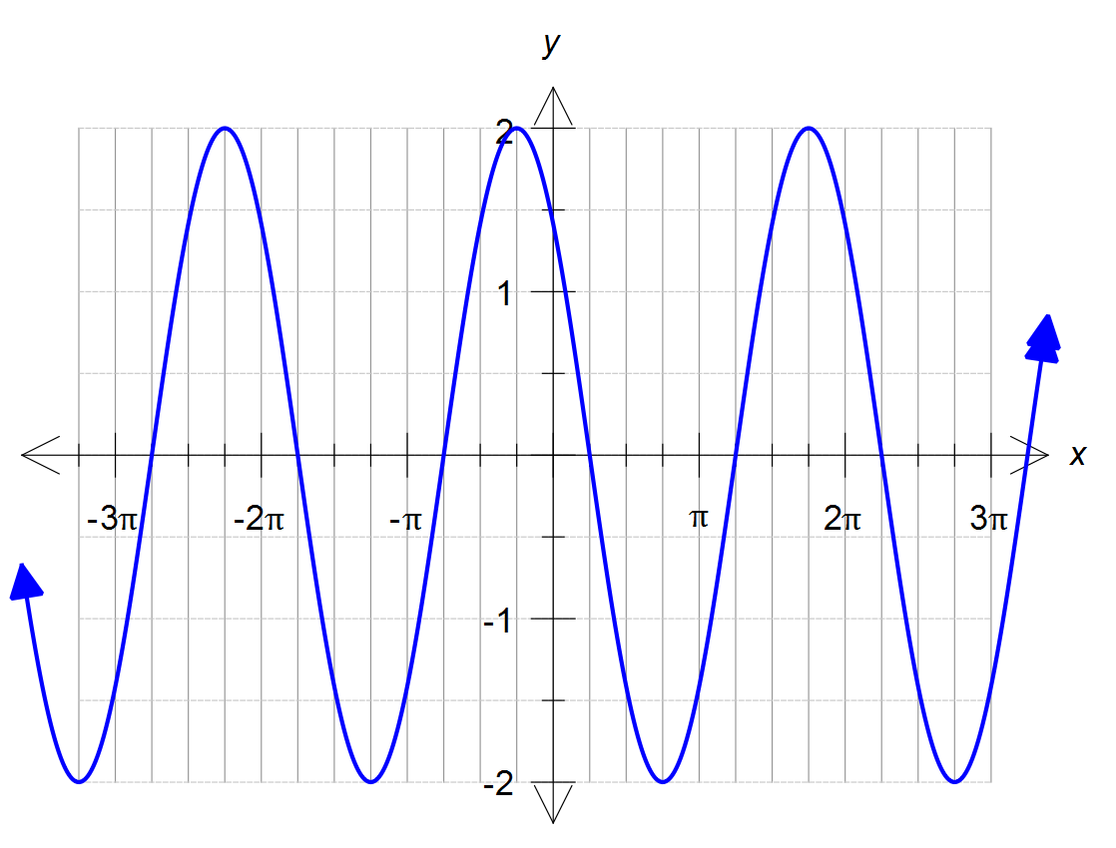

**Question 6 8 marks**

The first four rows of Pascal’s triangle are shown below.

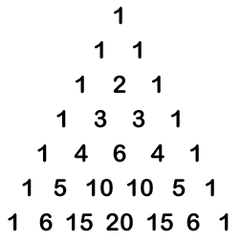

Simplify all answers in this question.

1. Expand the expression ${\left(x-2\right)}^{5}$. (2 marks)
2. Find the third term of the expansion of ${\left(2x-3y\right)}^{4}$ (2 marks)
3. How many different ways are there of selecting 3 students from a group of 7 students?

(2 marks)

1. For a community service project Mr Alderson wants to form a committee of three students and two staff. He has a total of 10 students to choose from. There are six staff who have indicated they are prepared to help. How many possible committees can be formed?

(2 marks)

**Question 7 7 marks**

1. Find the exact value of  (3 marks)
2. Solve $x^{3}+2x^{2}-4x-8$ = 0 (4 marks)

**Question 8 6 marks**

A sector of a circle, shown in the diagram, has a perimeter of 32 cm and an area of 60 cm2.

Determine all possible values of r and .

(Hint: first find the radius “r”).

**END OF SECTION ONE**

This page may be used for extra working space:

Question: ______